G.C.1-10 Lab Report

Name:
Z Number:
Lab TA’s Name and Section Number:
A statement Accountability: “I certify that this is my own work, and I understand that if I am found to be in violation of the honor code, I will be subject to the highest penalty.”

SUMMARY

Part I. Hydrides and Periodicity
- Determine the formulas of the hydrides of the following atoms:
C, N, O, F, Si, P, S, Cl
C - CH4
N - N2H4
O - H2O
F - HF
Si - SiH4
P - PH3
S - H2S
Cl - HCl
- Write these formulas in the appropriate place in Table 1 of your lab report.
- Complete Table 1 by determining the number of valence electrons and Lewis Structures of the hydride compounds.
- Determine the electron pair and molecular geometries of these compounds. Record your findings in Table 2 of your lab report.

Part II. Fluorinated Compounds
- Determine the electron pair and molecular geometries of the fluorinated compounds shown in Table 3. Record your findings in Table 3.

Part III. Hydrocarbons
- Draw a Lewis structure of methane, CH₄.
- Draw the Lewis structures of ethane, C₂H₆ and propane, C₃H₈.
- Draw Lewis structures of butane, C₄H₁₀.
- Enter the appropriate information in Table 4, and answer the appropriate questions in the laboratory report.

Part I: Hydrides and Periodicity
Table 1: Lewis Structures of Hydrides
Central Atom | Formula Of Hydride | Total # of Valence Electrons | Lewis Structure
C | CH4 | 8 | 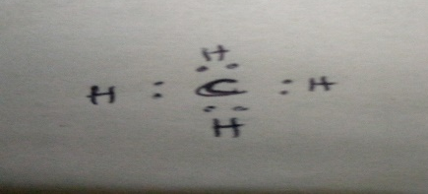
N | N2H4 | 8 | 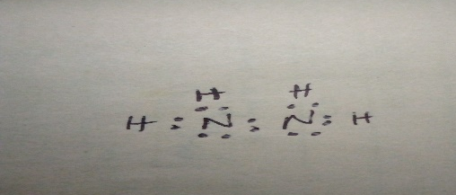
O | H20 | 8 | 
F | HF | 8 | 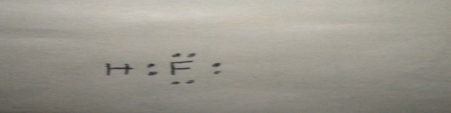
Si | SiH4 | 8 | 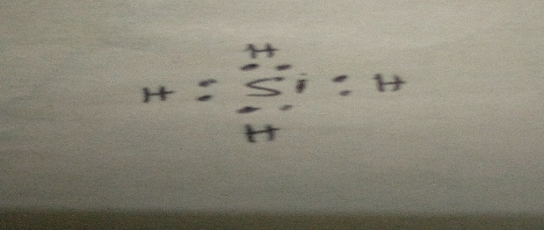
P | PH3 | 8 | 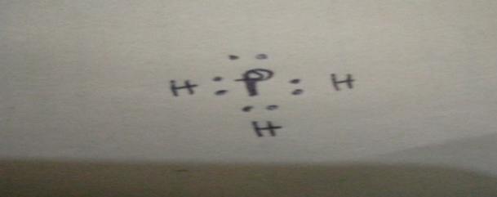
S | H2S | 8 | 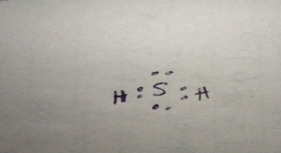
Cl | HCl | 8 | 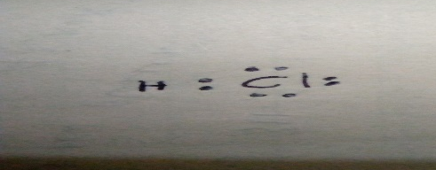

Part II, Table 2: Molecular Geometries
Central Atom | Formula of Hydride | # of Bonded Electron Pairs | # of Lone Electron Pairs | Electron Pair Geometry | Molecular Shape | Bond Angle(s)
C | CH4 | 4 | 0 | tetrahedral | tetrahedral | 109.5
N | N2H4 | 3 | 2 | trigonal planar | trigonal pyramidal | 112
O | H20 | 2 | 2 | tetrahedral | tetrahedral | 104.5
F | HF | 1 | 3 | trigonal bipyramidal | linear | 115
Si | SiH4 | 4 | 0 | tetrahedral | tetrahedral | 109.5
P | PH3 | 3 | 1 | pyramidal | trigonal pyramidal | 93
S | H2S | 2 | 2 | tetrahedral | bent | 90
Cl | HCl | 4 | 3 | tetrahedral | linear | 180

Part II. Fluorinated Compounds
Table 3: Fluorinated compounds
Molecule | Total # of E. Pairs around Central Atom | # Of Bonding Electron Pairs | # of Lone Pairs | Electron Pair Geometry | Molecular Geometry | Bond Angle(s)
PF₅ | 10 | 5 | 0 | trigonal bipyramidal | trigonal bipyramidal | 90 and 120
SF₄ | 8 | 4 | 1 | see saw | trigonal bipyramidal | 102 and 173
CIF₃ | 7 | 3 | 2 | t-shaped | t-shaped | 175
SF₆ | 12 | 6 | 0 | octahedral | octahedral | 90
BrF₅ | 6 | 5 | 0 | square pyramidal | square pyramidal | 90
XeF₄ | 6 | 4 | 2 | octahedral | square planar | 90 and 180
NF₃ | 6 | 3 | 1 | tetrahedral | trigonal pyramidal | 101.9

Part III: Hydrocarbons
Table 4: Hydrocarbons
Name | Formula | Lewis Structure
Methane | CH₄ | 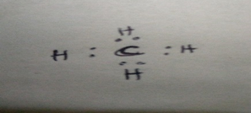
Ethane | C₂H₆ | 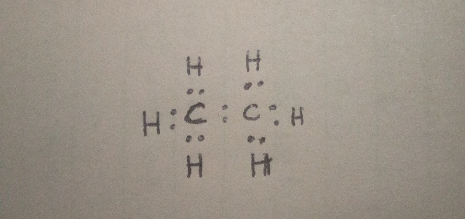
Propane | C₃H₈ | 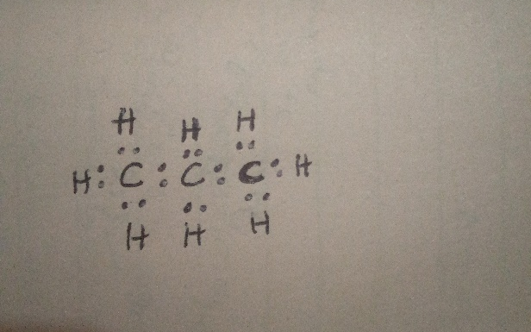
Butane (structure 1) | C₄H₁₀ | 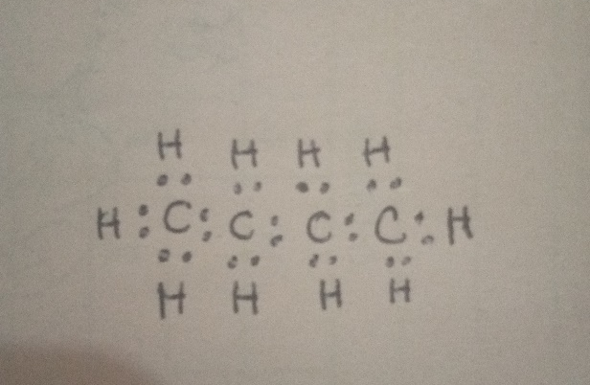
Butane (structure 2) | C₄H₁₀ | 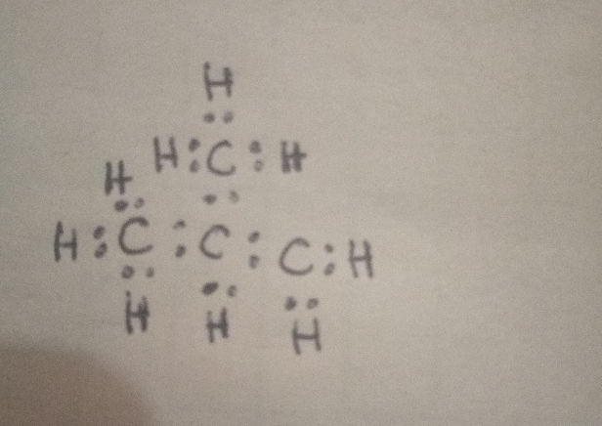

Discussion questions

Part I: Hydrides and Periodicity
- List the compounds that have similar molecular geometries.

CH4, H2O, and SiH4

- How can you relate the molecular geometries of these hydrides to the identities of the central atoms in these compounds?

These molecular geometries are determined by the number of electrons surrounding the central atom.

Part II. Fluorinated Compounds
- How many different molecular geometry are represented in these compounds?

There are 5 molecular geometries, including trigonal bipyramidal, t-shaped
Octahedral, square pyramidal, and square planar.

- Nitrogen and phosphorus are in the same group in the periodic table, but their fluorine-containing compounds have distinctly different stoichiometries and molecular shapes. Provide an explanation for this.
Nitrogen atoms have the ability to hold 8 valence electrons while phosphorus has an empty 3d orbitals, which can be used to expand the valence shell to hold 10 or more electrons.

Part III: Hydrocarbons
- What is the bond angle between the first, second and third carbon atoms in propane?

The bond angles are 112˚, 107˚, and 109˚.

- What is the bond angle between the first, second and third carbon atoms in the first structure of butane?
109.5˚, 109.5˚, and 110˚

- Are the bond angles you reported in Questions 1 and 2 the same? Explain why or why not.

The bond angles are different because of the different hybridization of the central atom.

- The two structures of butane whose models you built are called isomers. They have the same molecular formula but different arrangements of bonds in their structures. As a result, they can have different chemical and physical properties. Below, draw the Lewis structures of all of the isomers of pentane, C₅H₁₂.

Isomers are n-pentane, iso-pentane, and neo-pentane.
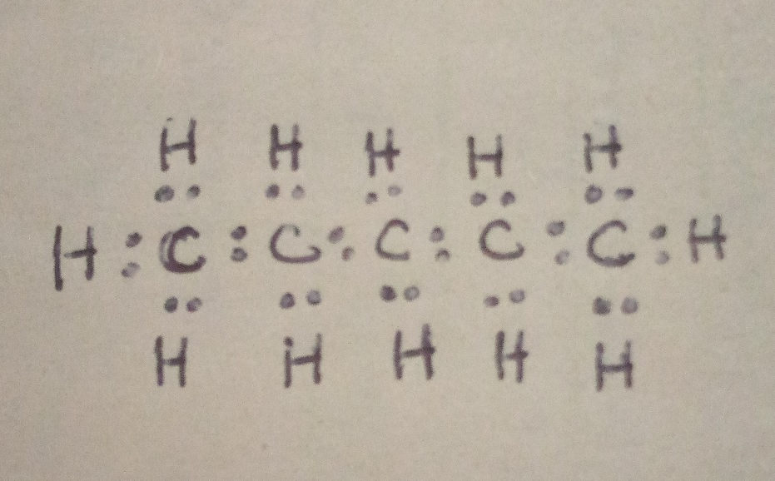
n-pentane
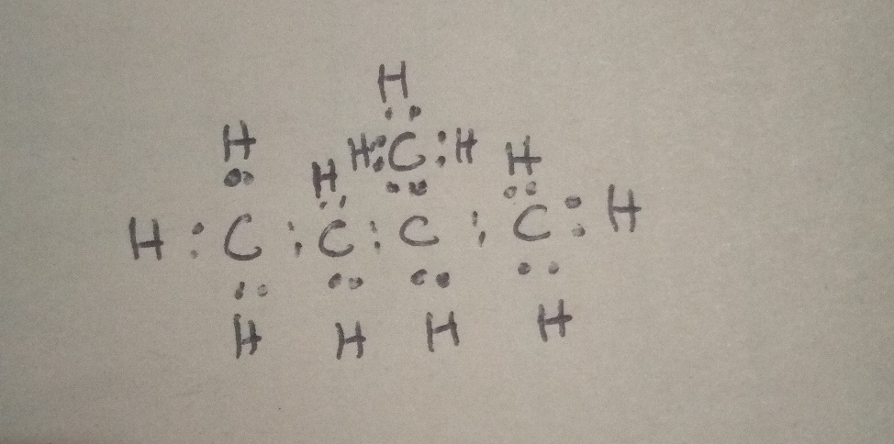
Iso-pentane
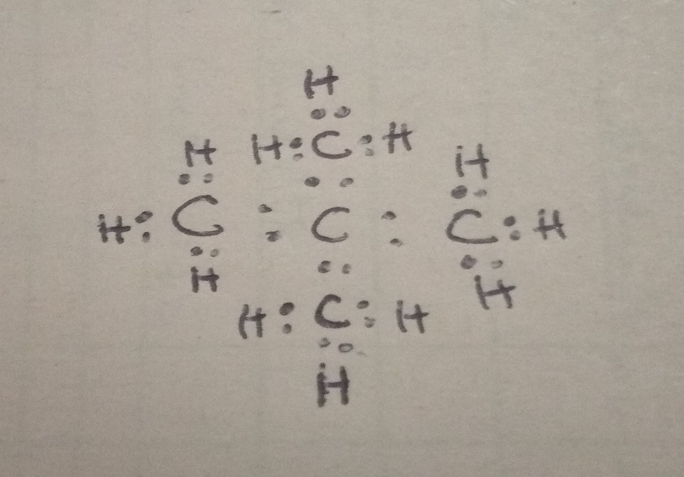
Neo-pentane

